**Q1. What is software? What is software engineering?**

**Software:** A set of instructions or programs that tell a computer what to do. It's a collection of data, instructions, and algorithms that manage, control, and utilize computer hardware components or perform specific tasks.

**Software Engineering:** The systematic application of engineering approaches to the development of software. It involves designing, building, testing, maintaining, and adapting software systems to meet specific requirements and ensure quality, reliability, and efficiency. Software engineering encompasses various stages, including analysis, design, implementation, testing, and maintenance, using various methodologies, tools, and techniques to produce high-quality software products

**Q2. Explain types of software**

1. System Software: Manages and controls computer hardware resources, such as memory, storage, and input/output devices, providing a platform for running applications and utilities.

2. Application Software: Performs specific tasks or provides services, such as word processing, web browsing, gaming, or social media, to meet individual or organizational needs.

3. Development Software: Helps create, test, debug, and maintain new software applications, including tools for programming languages, code editors, compilers, and version control systems.

4. Embedded Software: Controls and operates embedded systems and devices, such as traffic lights, microwave ovens, car navigation systems, and medical devices, to perform dedicated functions.

5. Firmware: Permanent software stored in device memory, controlling and operating device functions, such as router firmware, printer firmware, or smartphone firmware, to enable device operation.

6. Middleware: Connects and enables communication between different software systems, applications, and services, facilitating data exchange, integration, and interoperability, such as database management systems or messaging software.

**Q3. What is SDLC? Explain each phase of SDLC**

Software Development Life Cycle (SDLC) is a systematic process for planning, creating, testing, and deploying software applications. It provides a structured approach to software development and helps ensure the quality and efficiency of the final product. The SDLC typically consists of several phases, each with specific objectives and deliverables.

Steps of SDLC :

1. Planning:

Identifying project goals, scope, and resources needed to create a roadmap for the entire development process.

2. Analysis:

Gathering and understanding requirements, then examining how the system will meet those needs effectively.

3. Design:

Creating detailed blueprints for the system, including architecture, interface, and database design.

4. Implementation:

Writing the actual code and building the system according to the design specifications.

5. Testing and Integration:

Checking the system for errors and bugs, then combining all parts to ensure they work together smoothly.

6. Maintenance:

Ongoing updates and fixes to keep the system running efficiently and to address any new issues or requirements.

**Q4. What is DFD? Create a DFD diagram on Flipkart**

**Simple DFD for Flipkart**

**1. External Entities:**

* **Customer:** The end-user who browses products, places orders, and makes payments.
* **Supplier:** Provides the products listed on Flipkart.
* **Bank/Payment Gateway:** Facilitates payment transactions.

**2. Processes:**

* **1.0 Browse Products:**
  + Customer browses the product catalog.
* **2.0 Manage Cart:**
  + Customer adds or removes items from the shopping cart.
* **3.0 Place Order:**
  + Customer finalizes the order and enters payment details.
* **4.0 Process Payment:**
  + The payment gateway processes the payment.
* **5.0 Manage Orders:**
  + System updates order status and inventory.
* **6.0 Manage Products:**
  + Supplier updates product details and inventory.

**3. Data Stores:**

* **D1 Product Catalog:** Contains product details.
* **D2 Shopping Cart:** Stores items added to the cart.
* **D3 Orders:** Contains order details.
* **D4 Payment Details:** Stores transaction information.
* **D5 Inventory:** Manages product stock levels.
* 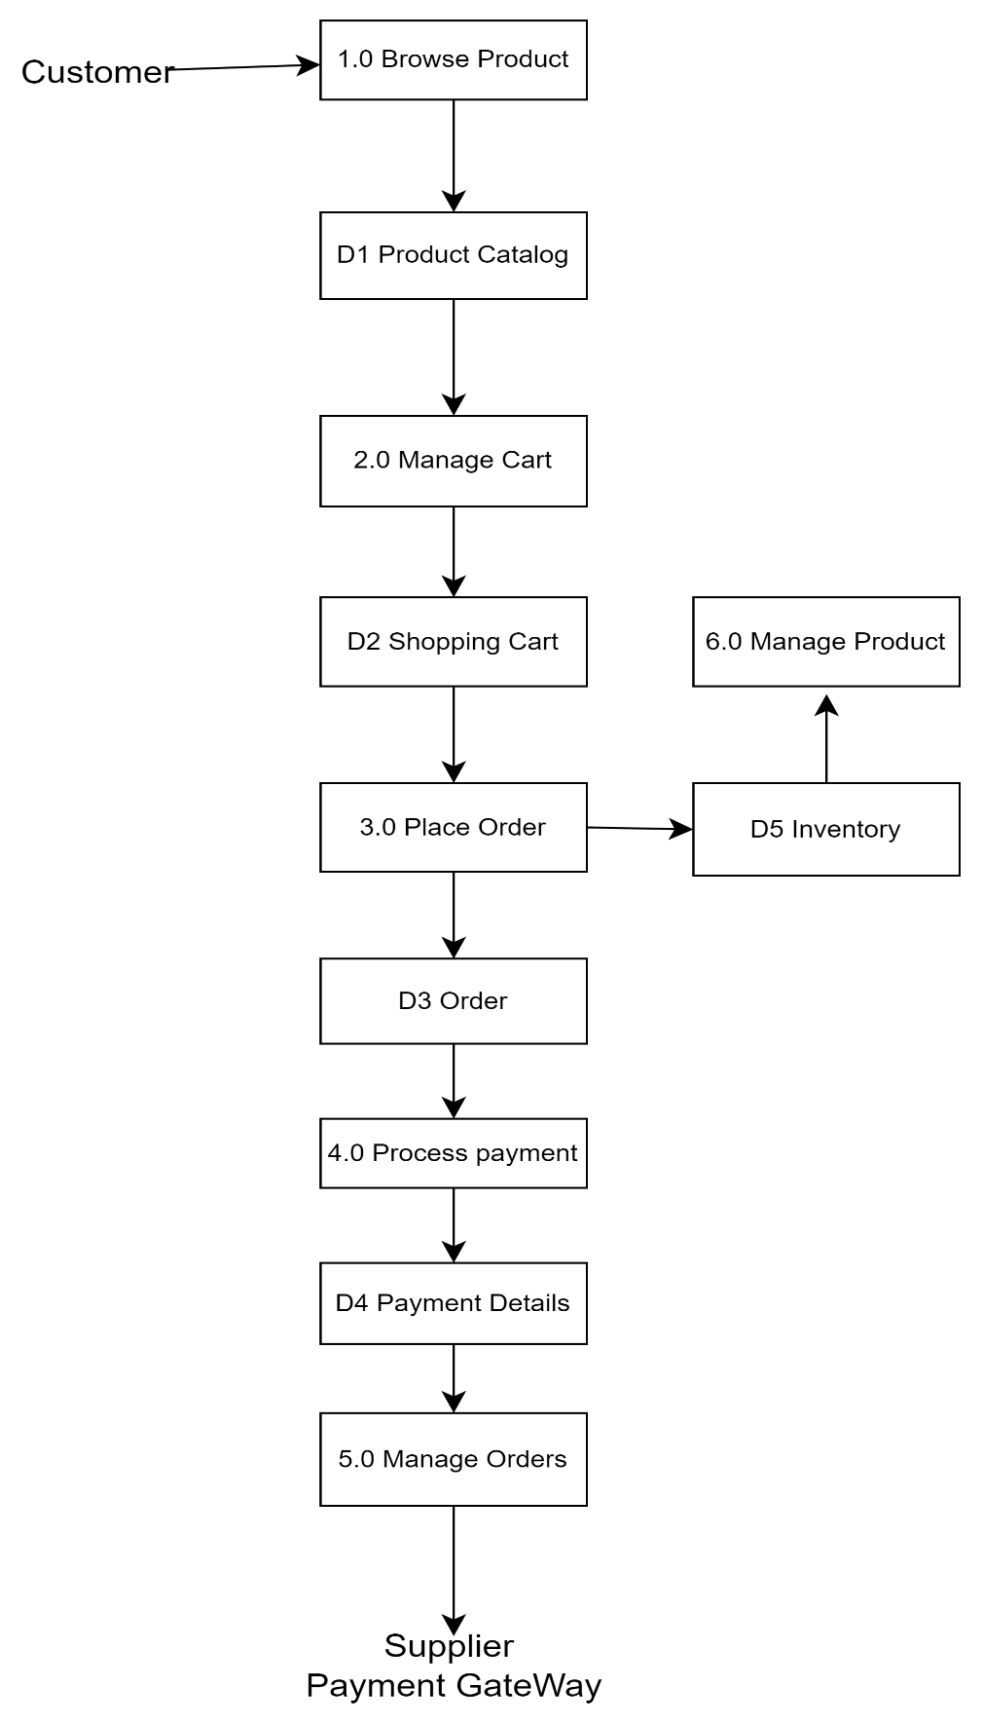

**Q5. What is Flow chart?**

A flowchart is a simple diagram that shows the steps to follow in a process or system. It's like a map that guides you through a series of actions, decisions, and results.

Think of it like a recipe:

1. Start (make a cake)

2. Mix ingredients (flour, sugar, eggs)

3. Decide: add chocolate chips or nuts?

4. Bake in oven

5. Check: is it done?

6. End (enjoy your cake!)

Flowcharts use basic shapes and arrows to connect the steps, making it easy to understand and follow the process.

It's a helpful tool to:

- Explain complex things simply

- Plan and organize tasks

- Solve problems step-by-step

- Show how things work

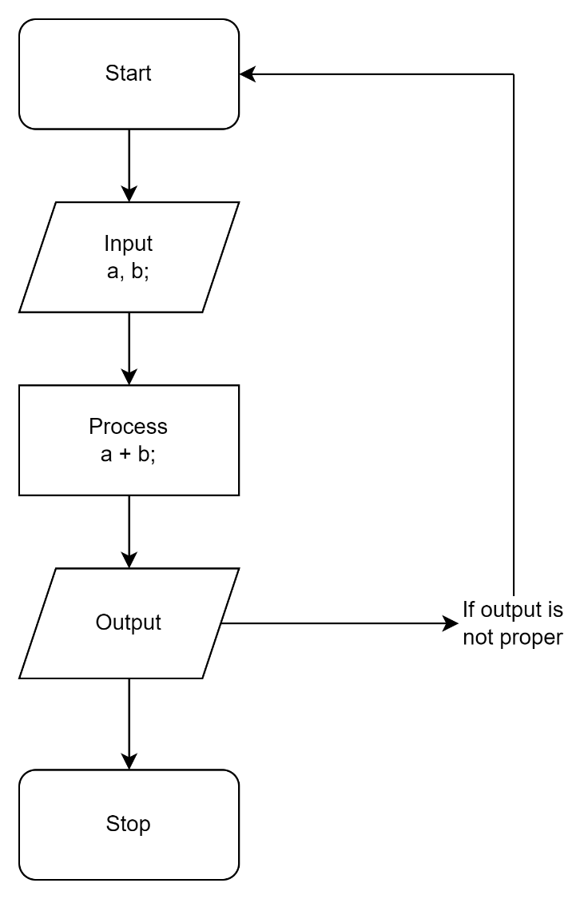

**Q6. What is Use case Diagram?**

A Use Case Diagram is a simple way to show how users interact with a system or product. It's like a blueprint that illustrates:

1. Who is using the system (users or actors)

2. What they want to achieve (goals or use cases)

3. How they interact with the system (actions or scenarios)

Think of it like a restaurant:

- Actors: Customers, Waiters, Chefs

- Use Cases:

- Customers: Order Food, Pay Bill

- Waiters: Take Order, Serve Food

- Chefs: Prepare Food, Manage Kitchen

**Use Case: Bill Payment on Paytm**

**Actors:**

1. **User:** The person using the Paytm app to pay bills.
2. **Paytm System:** The backend system that processes payments and manages user data.
3. **Bank/Payment Gateway:** Facilitates the transaction between the user and the service provider.
4. **Service Provider:** The company or entity to which the bill payment is made (e.g., electricity company, mobile operator).

**Use Cases:**

1. **Login/Register:**  
   The user logs into their Paytm account or registers if they are a new user.
2. **Select Bill Payment Option:**  
   The user selects the type of bill they want to pay (e.g., electricity, mobile, DTH).
3. **Enter Bill Details:**  
   The user enters the required bill details, such as customer ID, account number, etc.
4. **View Bill:**  
   The system retrieves and displays the bill details for the user to review.
5. **Choose Payment Method:**  
   The user selects a payment method (e.g., credit card, debit card, UPI, wallet balance).
6. **Confirm Payment:**  
   The user confirms the payment details and authorizes the transaction.
7. **Process Payment:**  
   The Paytm system processes the payment via the bank/payment gateway.
8. **Payment Confirmation:**  
   The system provides a confirmation of the successful payment to the user.
9. **Send Receipt:**  
   A receipt of the payment is generated and sent to the user via SMS, email, or within the app.

